Student Name: Lakshay Aggarwal UID: 25MCI10122
Branch: MCA (AI & ML) Section: 25MAM_KAR-1
Semester: 2 Date of Performance: 3/2/26 Subject Name: Technical Training -I Subject Code: 25CAP-652

EXPERIMENT – 04
Implementation of Iterative Control Structures using FOR, WHILE, and LOOP in PostgreSQL

Aim
To understand and implement iterative control structures in PostgreSQL conceptually, including FOR loops, WHILE loops, and basic LOOP constructs, for repeated execution of database logic.

Tools Used
- PostgreSQL

Objectives
- To understand why iteration is required in database programming
- To learn the purpose and behavior of FOR, WHILE, and LOOP constructs
- To understand how repeated data processing is handled in databases
- To relate loop concepts to real-world batch processing scenarios
- To strengthen conceptual knowledge of procedural SQL used in enterprise systems

Experiment Steps

Step 1: FOR Loop – Simple Iteration
create table employees(
e_id serial primary key,
e_name varchar(50),
e_salary numeric(10,2)
);

insert into employees (e_name, e_salary) values
('Lakshay', 40000),
('Neha', 50000),
('Tushar', 48000),
('Sam', 35000),
('Diya', 49000);

do $$
begin
for i in 1..5 loop
raise notice 'Iteration Number: %', i;
end loop;
end;
$$ ;

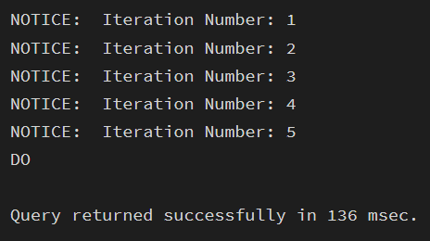

Example 2: FOR Loop with Query (Row-by-Row Processing)
do $$
declare
emp_rec RECORD;
begin
for emp_rec in
select e_id, e_name from employees
loop
raise notice 'Employee ID: %, Name: %', emp_rec.e_id, emp_rec.e_name;
end loop;
end;
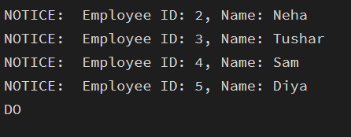
$$;

Example 3: WHILE Loop – Conditional Iteration
do $$
declare
counter INT := 1;
begin
while counter <= 5 loop
raise notice 'Counter value: %', counter;
counter := counter + 1;
end loop;
end;
$$ ;
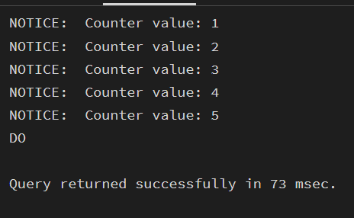

Example 4: LOOP with EXIT WHEN
do $$
declare
counter int := 1;
begin
loop
raise notice 'Counter value: %', counter;
counter := counter + 1;
exit when counter > 5;
end loop;
end;
$$ ;
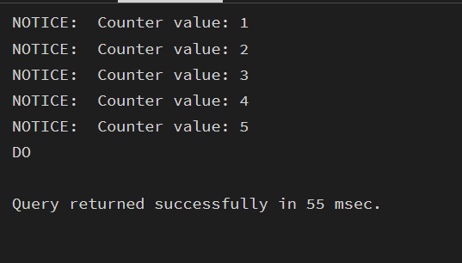

Example 5: Salary Increment Using FOR Loop

do $$
declare
emp_rec RECORD;
begin
for emp_rec in
select e_id, e_salary from employees
loop
update employees
set e_salary = e_salary * 1.10
where e_id = emp_rec.e_id;

raise notice 'Updated salary for Employee ID: %', emp_rec.e_id;
end loop;
end;
$$ ;

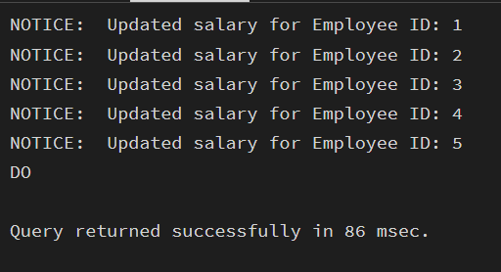

Example 6: Combining LOOP with IF Condition
do $$
declare
emp_rec RECORD;
begin
for emp_rec in
select e_id, e_salary from employees
loop
if emp_rec.e_salary > 50000 then
raise notice 'Employee ID % has salary more than 50000', emp_rec.e_id;
else
raise notice 'Employee ID % has salary less than 50000', emp_rec.e_id;
end if;
end loop;
end;
$$;
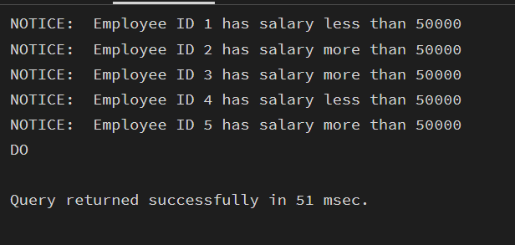

Learning Outcome

- Understand the need for iteration in database applications.
- Identify and use different loop types (FOR, WHILE, LOOP).
- Implement fixed and query-based repetition for row processing.
- Apply conditional and exit-controlled loops for automation tasks.
- Use PL/pgSQL loops in real-world scenarios like payroll, reporting, and batch processing.

Result
This experiment helps students understand how iterative control structures work in PostgreSQL at a conceptual level. Students learn where and why loops are used in database systems and gain foundational knowledge required for writing procedural logic in enterprise-grade applications.

